Submitting ESS Job from OIC For Purge ESS Job
Name of the Integration:
purge_ess_job
Integration Type:
Scheduled Orchestration
Package of the integration:
financials
Purpose of the integration:
This integration is designed to purge the BU Names.
Requirement:
To Purge the BU using the integration so that it avoids duplicating.
Steps followed are below
- Created DB Adapter Connection.
- Connection Name : Retrieve Paramater Values from DB
- Created ERP Cloud Connection to Dev3
- Connection Name : Erp Cloud Submit Ess Job Conn_purge
For_Each_BU :
We have used For loop component in between the above two connections to iterate through multiple BU’s .
Below is the Design Diagram of the integration developed.
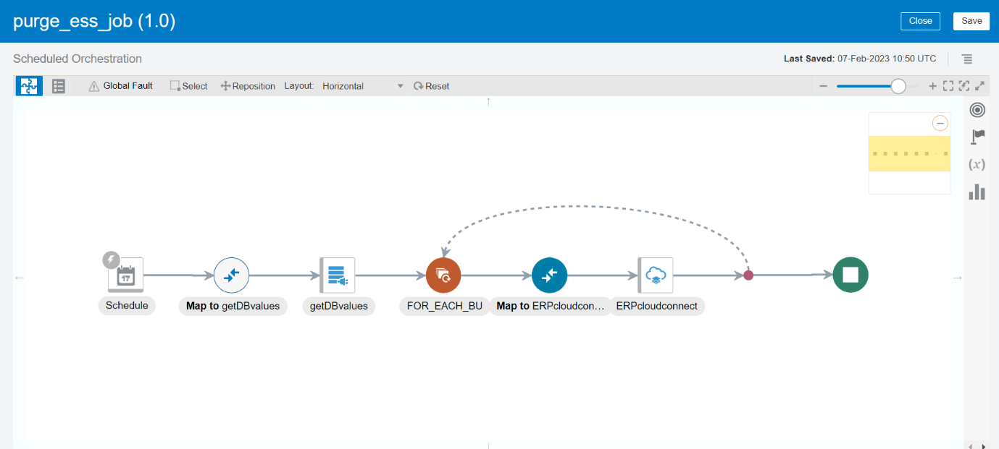
Fig 1: shows the design diagram of the integration purge_ess_job
Retrieve Paramater Values from DB Adapter :
The purpose of the DB adapter is to get the bu_id values from Database.
Get DB Values DB adapter Configuration
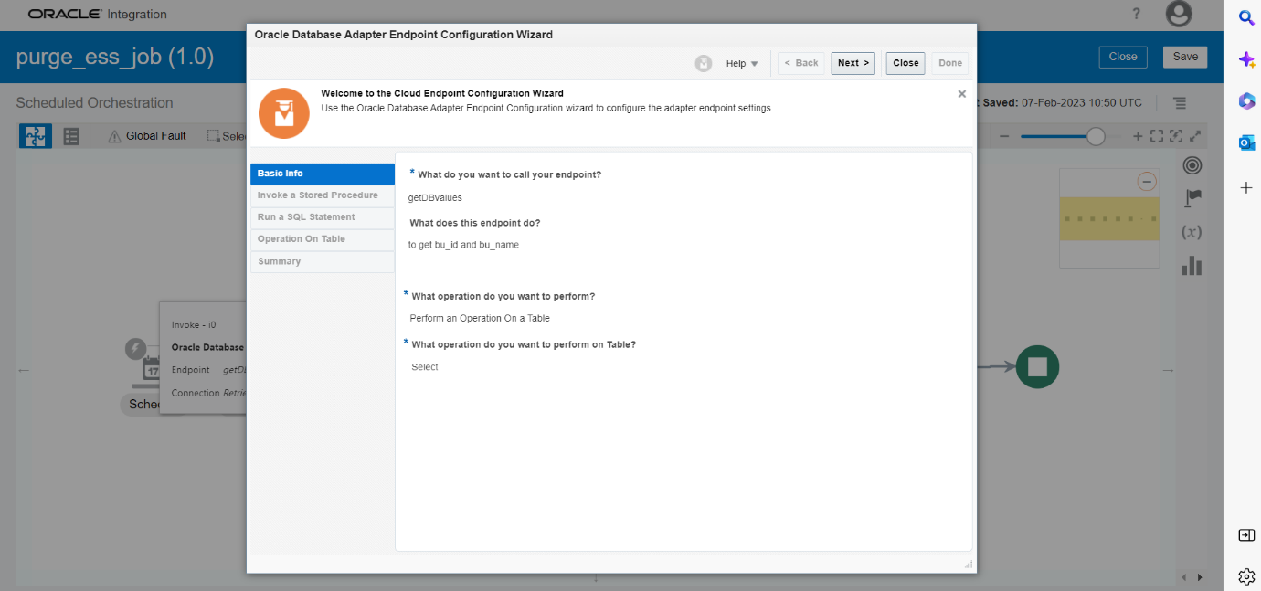
Fig 2: shows the name of the endpoint, purpose of endpoint and operation to be performed on a table

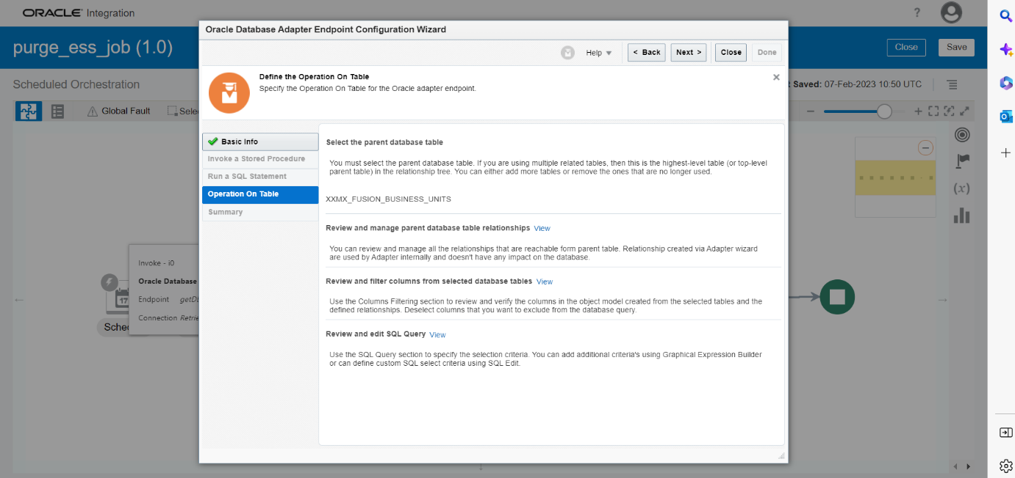
Fig 3: shows the options to be performed on a table (selected: Review and edit SQL Query)

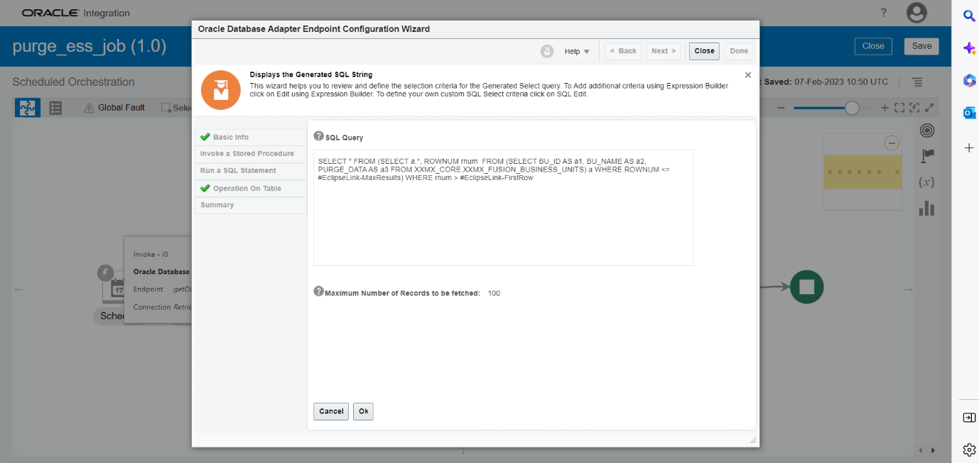
Fig 4: SQL Query(Internally selected the tables and columns from xxmx_core schema by selecting the Review and edit SQL Query )
SQL Query:
SELECT * FROM
(SELECT a.*, ROWNUM rnum FROM
(SELECT BU_ID AS a1, BU_NAME AS a2, PURGE_DATA AS a3 FROM
XXMX_CORE.XXMX_FUSION_BUSINESS_UNITS) a
WHERE ROWNUM <= #EclipseLink-MaxResults)
WHERE rnum > #EclipseLink-FirstRow

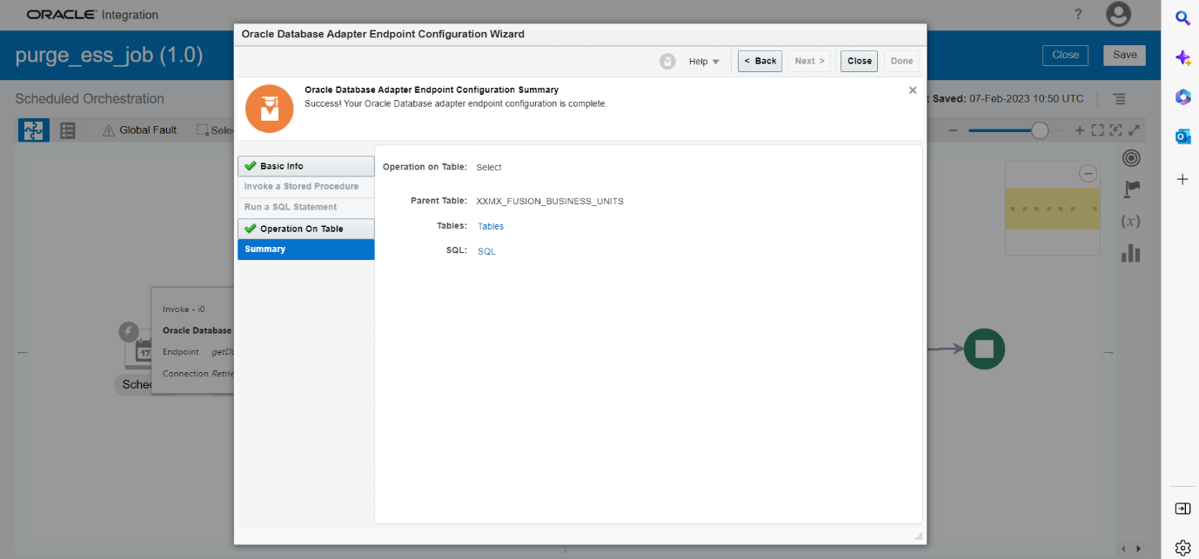
Fig 5: Summary for connection “Retrieve Paramater Values from DB”
Erp Cloud Submit Ess Job Conn_purge Adapter:
The purpose of the Erp Cloud Submit Ess Job Conn_purge Adapter is to connect to the Fusion or cloud of dev3 by giving the credentials in the connection created.

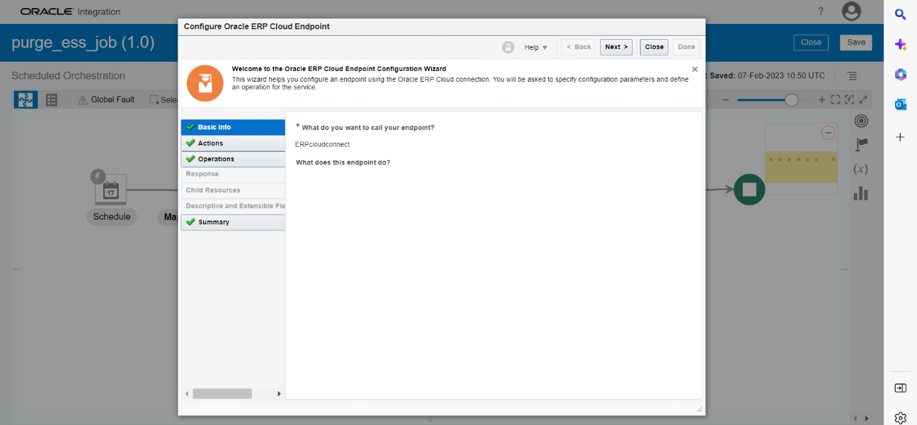
Fig 6: shows the name of the endpoint of Erp Cloud Submit Ess Job Conn_purge

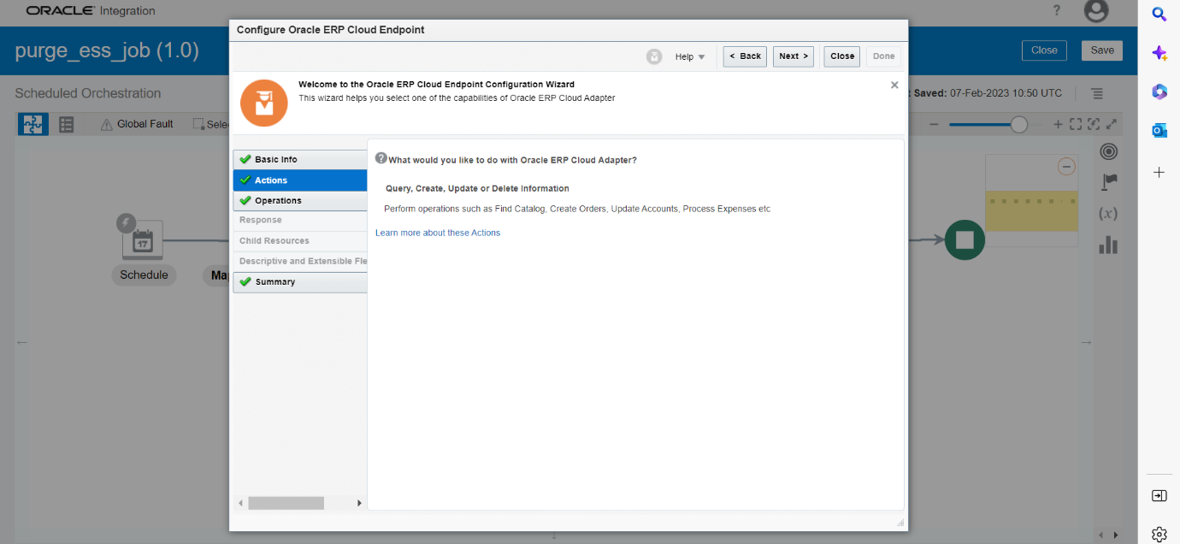
Fig 7: shows the actions to be performed on ERP cloud Adapter

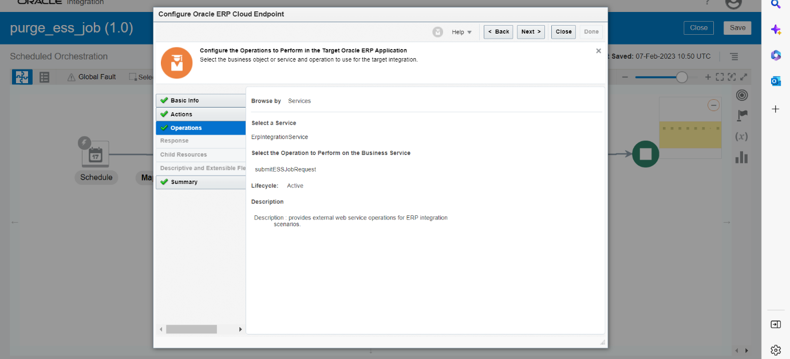
Fig 8 : shows the operations to be performed on ERP cloud Adapter

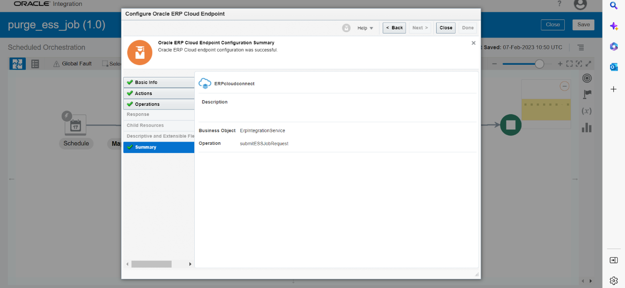
Fig 9: Summary for connection “Erp Cloud Submit Ess Job Conn_purge Adapter

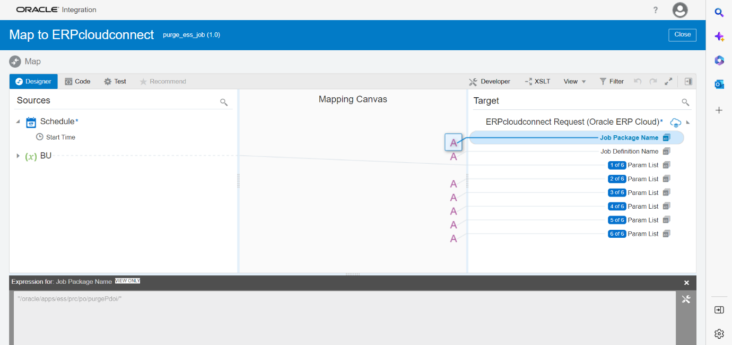
Fig 10: Shows the Job package name "/oracle/apps/ess/prc/po/purgePdoi/"

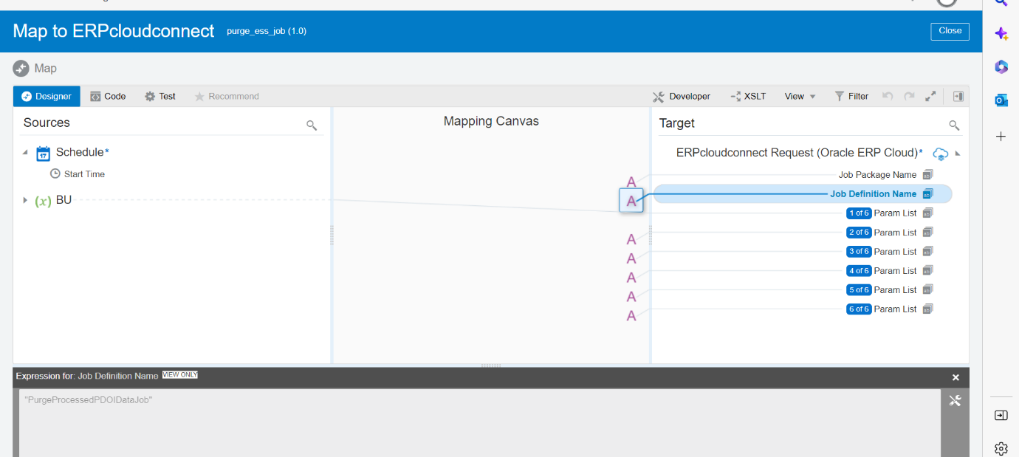
Fig11: Shows the Job Definition Name "PurgeProcessedPDOIDataJob"

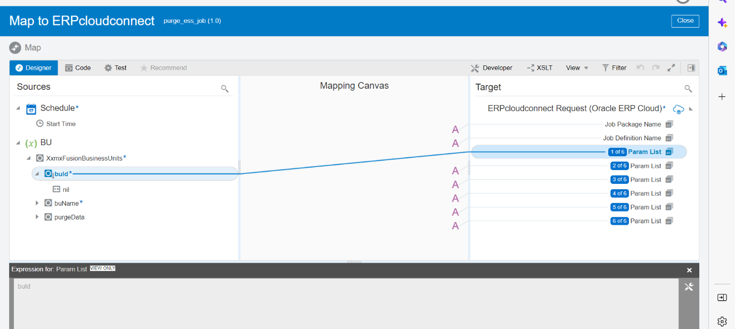
Fig 8: shows the mapping to the parameters
Mappings :
Job Package Name : "/oracle/apps/ess/prc/po/purgePdoi/"
Job Definition Name : "PurgeProcessedPDOIDataJob"
Parameter 1: mapped to buId
Parameter 2: hardcoded as "PO"
Parameter 3: hardcoded as "A"
Parameter 4: hardcoded as " "
Parameter 5: hardcoded as " "
Parameter 6: hardcoded as " "

Conclusion:
Activity | Count
For Each | 1
Invoke | 2
Map | 2
Schedule | 1
Total | 6

